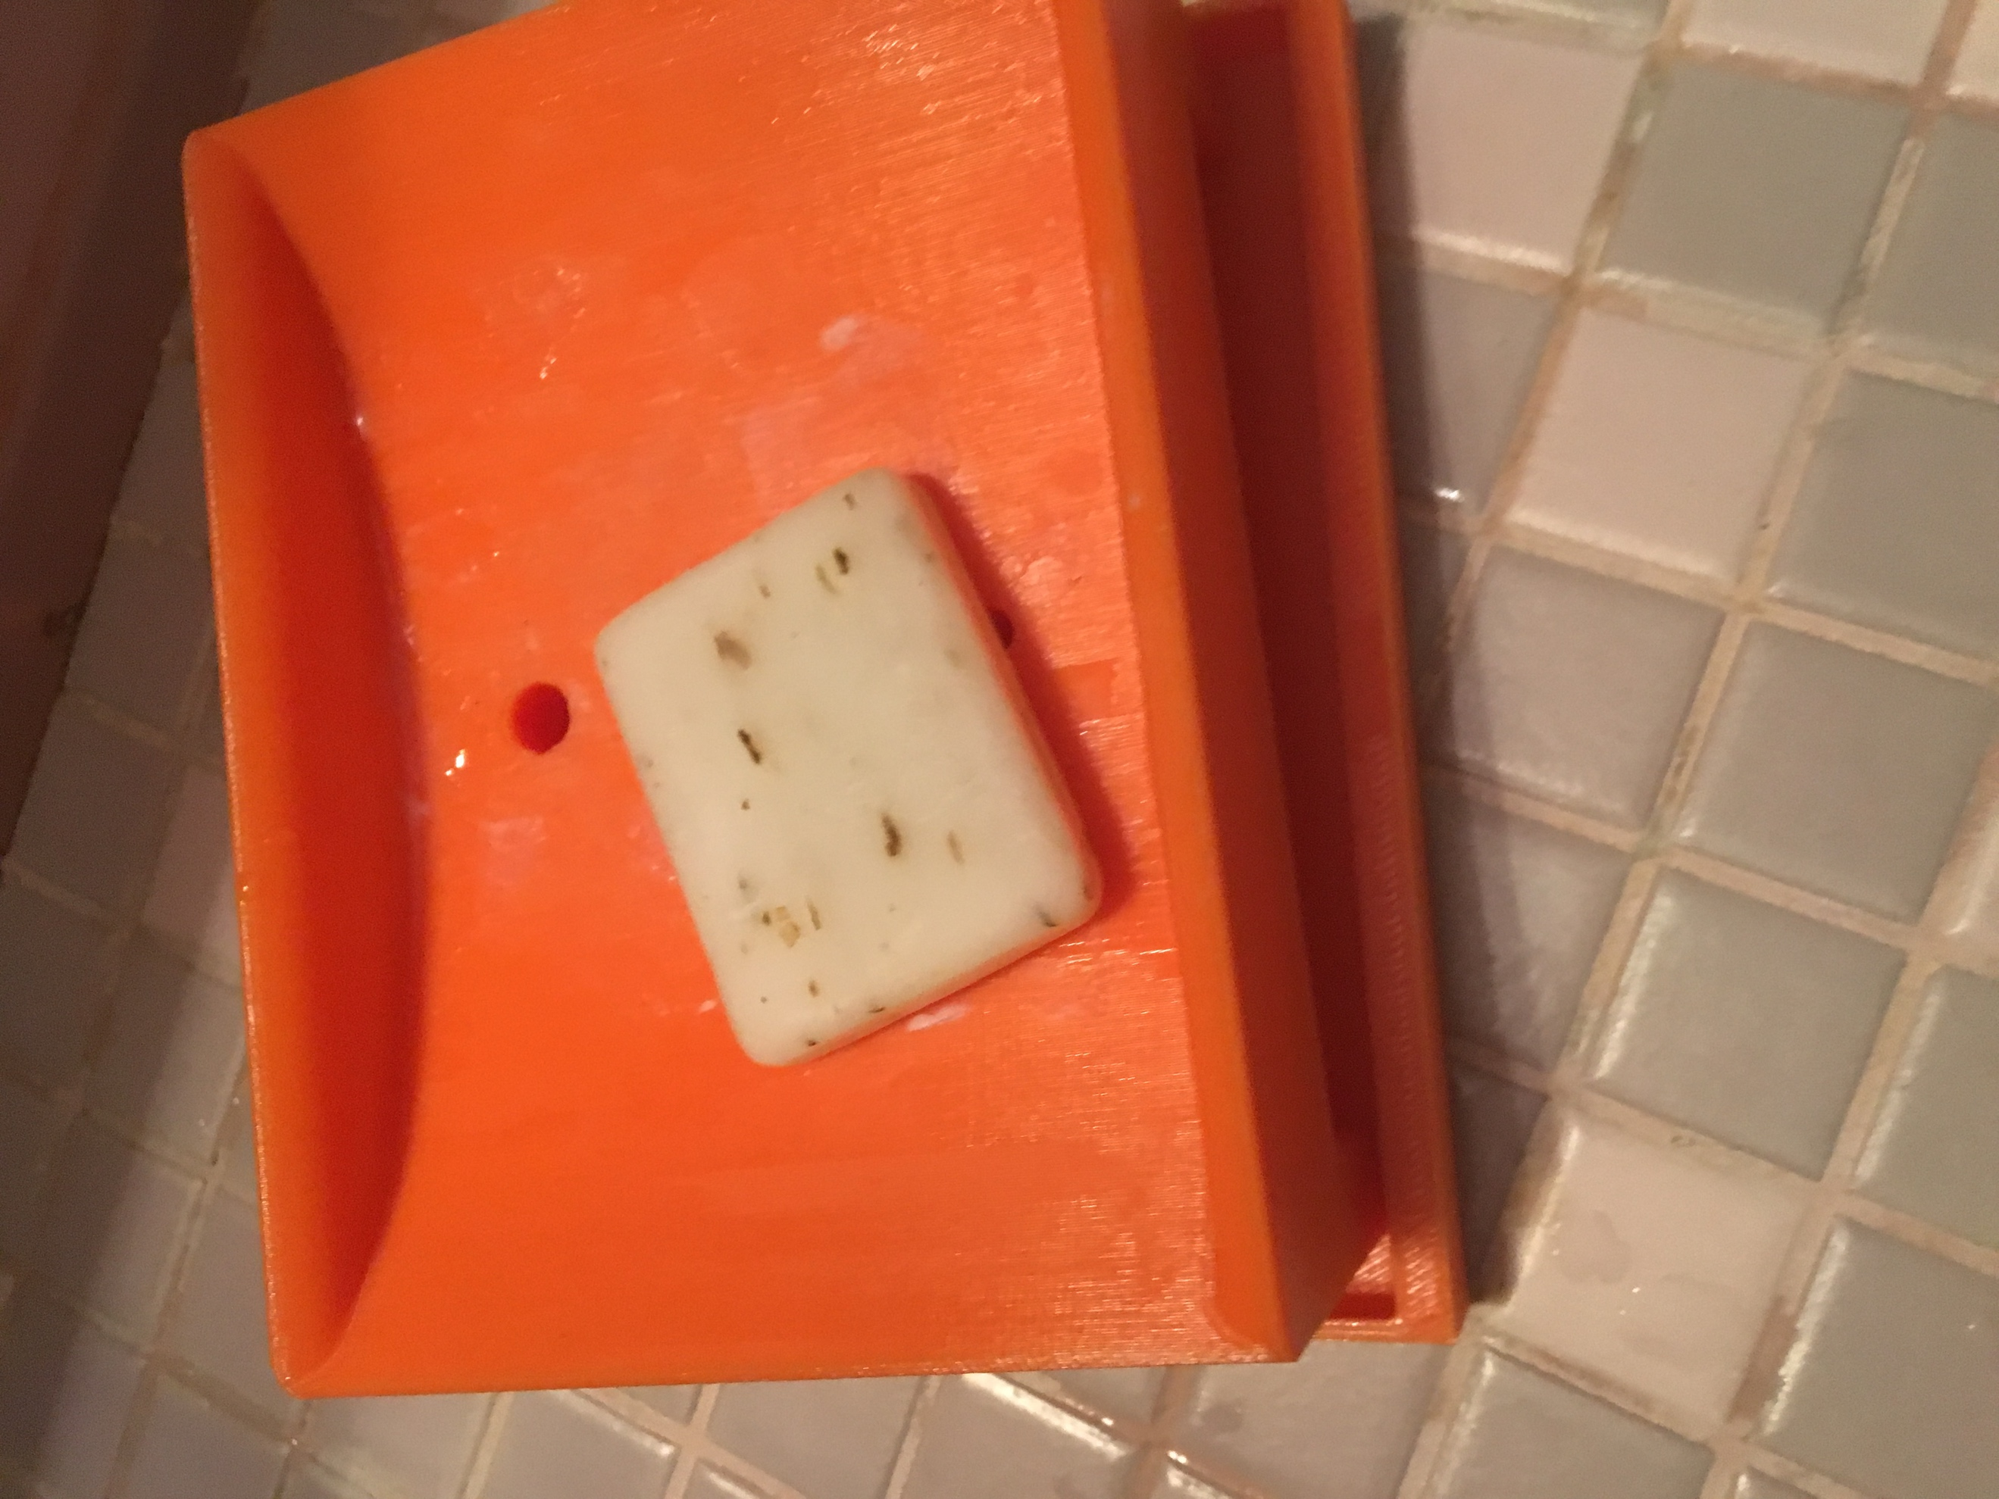Soap Holder

I originally created this idea at home. Then at 3D designing competition our team and I improved the design and used this thing. As a consequence of that we won judge’s special award. The idea came from my dad he was complaining about how soaps were melting in a normal soap holder. Then he asked me whether I can do something for it or not. Then I started creating this thing and we finished it in the competition. It is a soap holder with holes and under it there is a cup to hold the water. Thanks to that soap is not melting and wasted water is collected.